Civil Rights Complaint Procedure
Management recognizes the right of every employee and customer to file an external complaint, independent of any action the complainant may wish to take or not take, with the Manager of Equal Employment Opportunity/Diversity Development or designated representative.

However, to insure prompt, fair and impartial internal processing of complaints alleging discrimination;

A complainant is urged to use the opportunity for internal discussion of grievances and to consult with the Manager of EEO/ Diversity Development or designated representative prior to filing a formal complaint of discrimination with State of New York Division of Human Rights, the U.S. Equal Opportunity Commission and/or appropriate federal department(s).

Such consultation should be made within 10 calendar days from the date of alleged discriminatory act unless the discrimination is continuing in which case the complainant should consult with the Manager of EEO/ Diversity Development or designated representative as soon as convenient. Any employee or customer who is of the belief that he/she has been discriminated against because race, color, religion, national or ethnic origin, age, alienage, citizenship, ancestry, gender, genetic disposition, or carrier status, sexual orientation, marital status, liability for service in the Armed Forces of the United States, arrest/ conviction record, or disability should consult with the Manager of EEO/Diversity Development or designated representative in an effort to resolve the matter informally.

The Manager of EEO/Diversity Development or designated representative will:
- Make necessary inquires to seek a resolution of the matter on an informal basis.
- Have access to officials at all levels when looking into an equal employment opportunity matter in an attempt to resolve/conciliate it.
- Discuss with an appropriate official the findings and his/her recommendations for a resolution of the problem.
- Process the complaint to informal resolution within 45 days after the matter is brought to his/her attention.
- Supervisors at all levels shall insure that the Manager of EEO/Diversity Development or designated representative receives full cooperation at all levels when handling equal opportunity complaints.
- Assure that a complainant may file written complaints with the Manager of EEO/Diversity Development and these will be investigated by same.
- The Manager of EEO/Diversity Development will have access to all records, documents, memoranda, etc. necessary to conduct a review of the complaint.
- The Manager of EEO/Diversity Development will respond to formal written complaints with a written report of findings and recommendations for resolving same.
- Assure appropriate follow-up is conducted after complaints are settled to forestall and correct harassment or retaliatory actions against the employee.
- Make periodic checks to assure that agreed upon corrective action is continuing or has been taken.
- Analyze employee complaints, formal or informal, in order to identify conditions and circumstances that may exist beyond the individual case which require further investigation.
- Recommend corrective action where an investigation reveals discriminatory action by a supervisor to the Executive Director.

Assure the “Complaint Procedures” are posted on all employee bulletin boards, together with information as to where and with whom complainants.

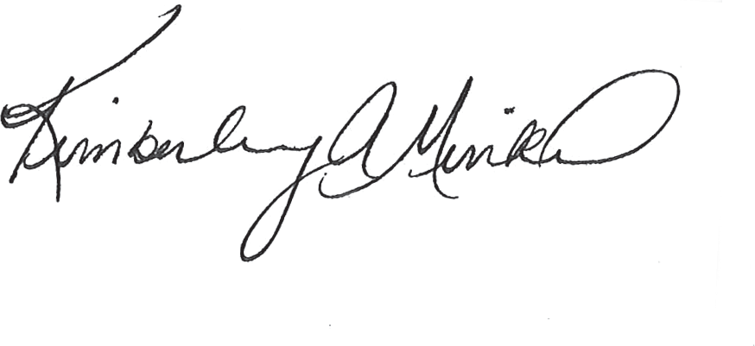Date

Kimberley A. Minkel Executive Director

9/1/16

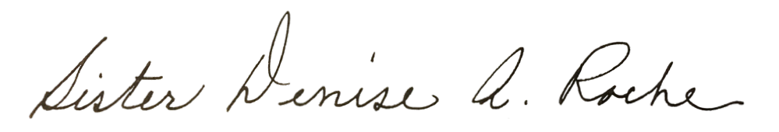Sister Denise A. Roche Chair

9/1/16

Date

